Student Leadership Meetings

    - November 14
    - December 19
    - January 16
    - February 13
    - March 13
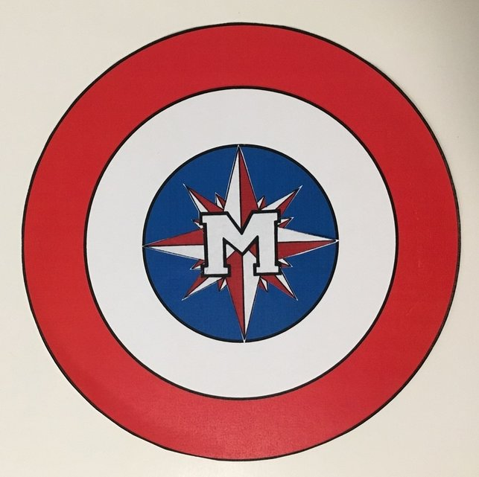
    - April 17
    - May 15
    - June 5
8:15 AM

